TASK 1

From Workbook 1:

Change the first System.out.print line to be:

System.out.println("What a wonderful world");

Instructions:

1. Write how it is, where it says hello 4cs001 student, change that to what a wonderful world. Exactly how it is written in the screenshot.

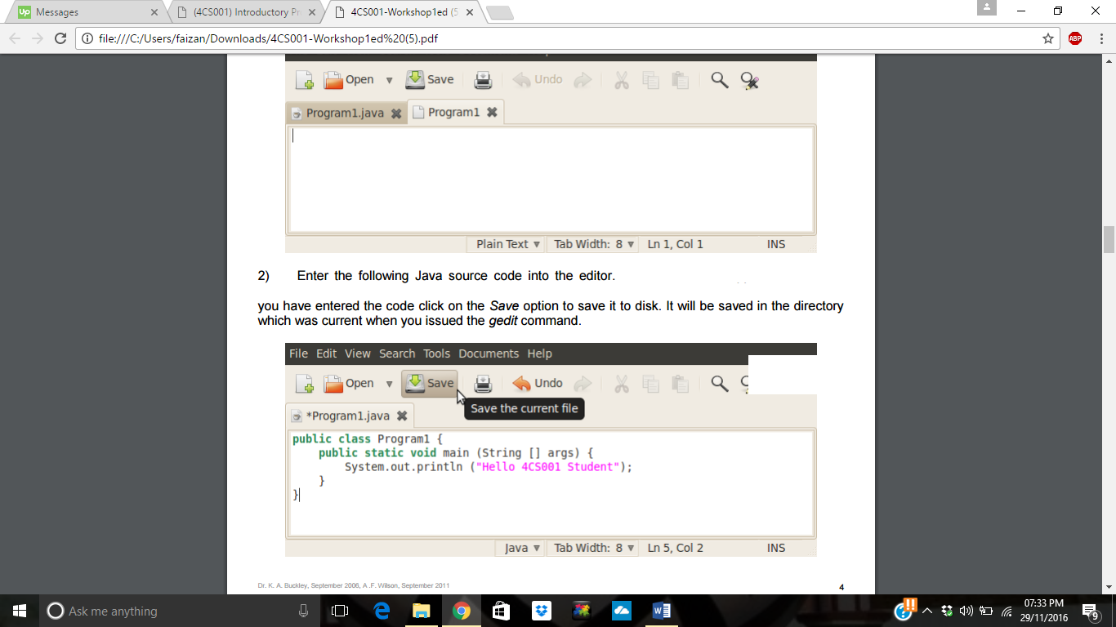

Solution

public class Program1{

public static void main(String args[]){

System.out.println("what a wonderful world. ");

}

}